After installing this tool you will need to create a project and provide the information for connecting to your wsdl file.

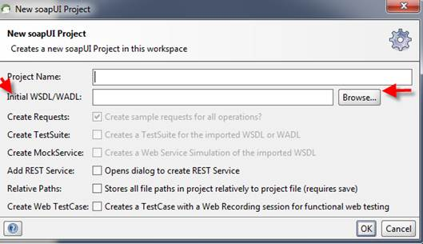

Once you have created the project you will see all the available soap calls.

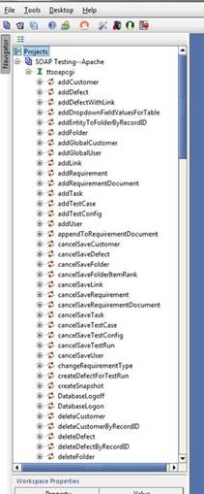

Select ProjectLogon from the list expand the + sign and double click on the Request window and you will see the following screen.  This is all the required and optional fields that are needed to log into the TestTrack Project through SOAP.  Everywhere there is a ? you need to replace the ? with your information.  If it is an optional field and you do not want to provide any information you will change >?< to ><(the only exception to this is the CProjectDataOption, soapUI incorrectly shows this as optional and it is actually required).    So in this Case the name field is the name of the TestTrack Project you are connecting to, the CProjectDataOption is the License you are logging in with, if you only have 1 server there is no need for a servernumber, username and password of a user who is a member of the project and in a security group.  (Scroll down)

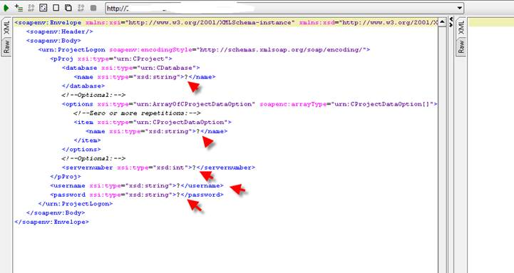

Here is an example of what the project login should look like after entering all your information:

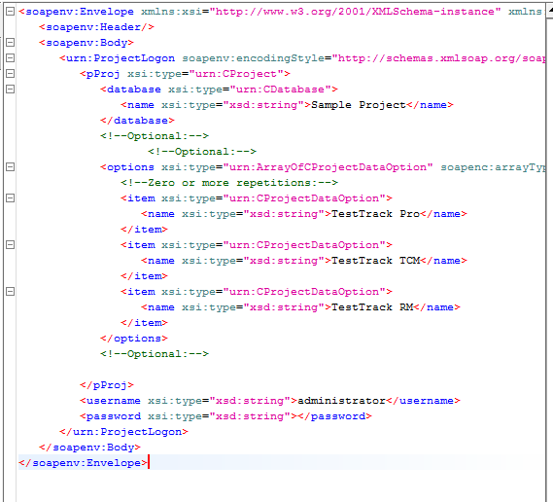

Once you have all your information entered click the green arrow to submit your information and if it is successful you will see the response shown in the split screen on the right which is a cookie to be used when performing other soap calls.  If you can successfully do this then you know that the SOAP components are correctly configured.

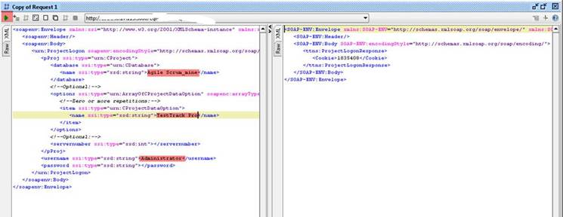

Once you have received the cookie find the “getDefect” call in the list, select the + sign, and double click on “Request 1”. Add the cookie in the appropriate spot and the defect number of the defect you would like to receive information from. Remove the question mark from the summary tag and add “false” to the downloadAttachment tag as pictured below:

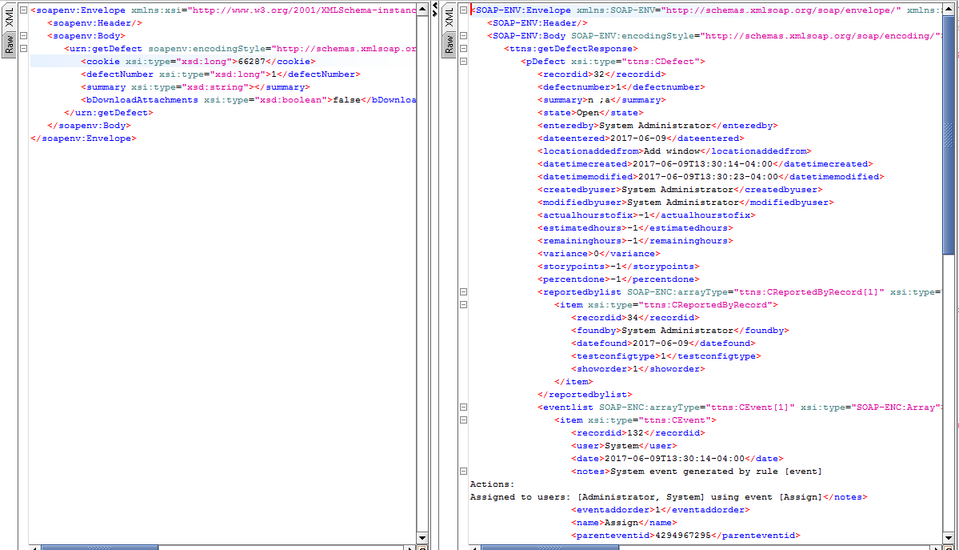

You should see all the attributes in the right pane